1、open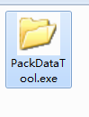，press Config，Add to the right-click menu for easy packaging later;

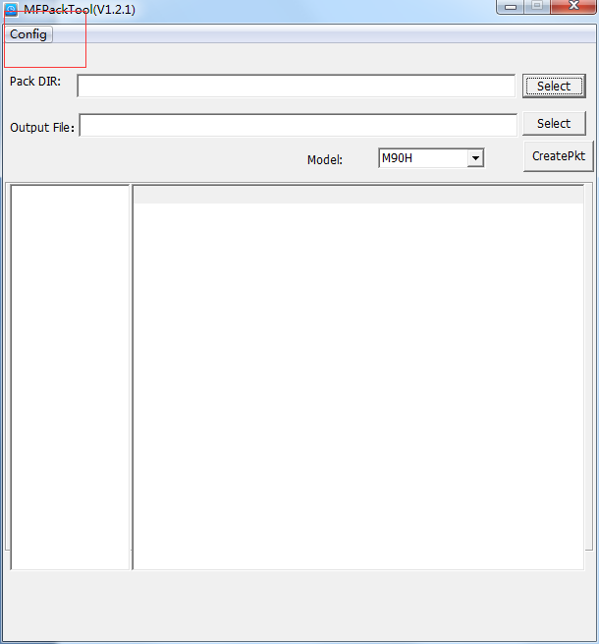

2、Add a folder include a folder named "data",input your image or other data files into the folder named "data".You can edit the file named "data.ini" to change the data version,and do not edit the file named "CHECK.ini".

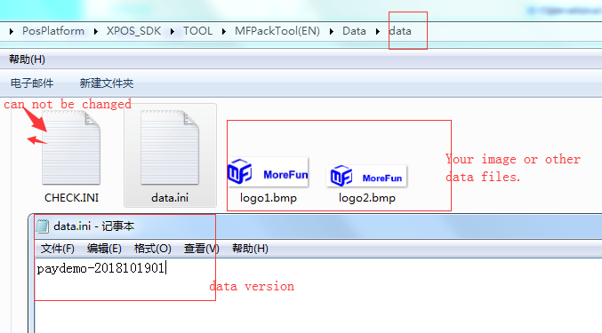

3、Right click on the folder containing the "data" subfolder and select“MF_dataPack”in the pop-up context menu. Press the package in the pop-up tool interface, and package the successful data packet as shown below.

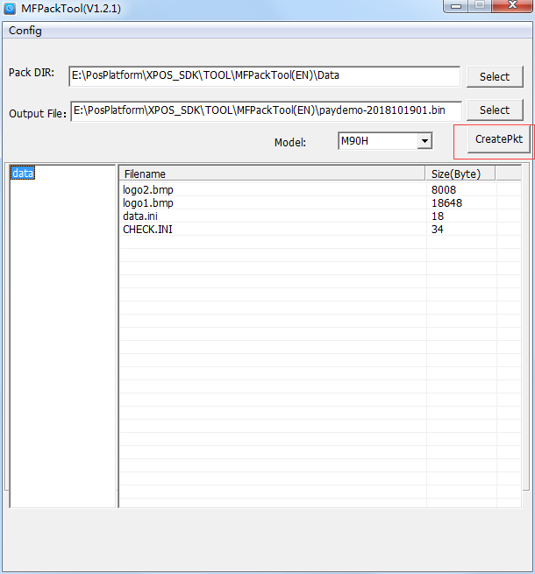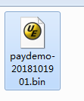

4、Press #5555# to enter the data download mode on the device standby interface.Download the packet to the terminal.

